Warning – Diesel - Low Fuel Pressure – CGEA1.3

Functional Description

The purpose of the Fuel Pressure Warning messages is to inform the driver of a drop in the Fuel System Pressure. It is used for diesel applications because low fuel pressure may lead to diesel engine damage.

The Fuel Pressure Warning Display correlates the FuelFilterLamp_B_Dsply signal from the ECM and the Operational_Mode to determine when to display the Fuel Pressure Warning Message.

1.2 Interfaces

1.2.1 Interface Context Diagram (I/O Block Diagram)

Figure 1: Pressure Fuel Warning Messages Context Diagram

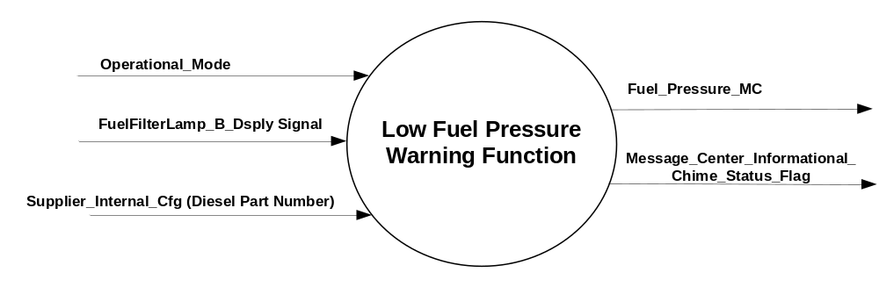

1.2.2 Inputs
      - INTERNAL:
    - Operational_Mode
    - MUX message from the CAN bus

- FuelFilterLamp_B_Dsply (HS_CAN) Signal
Signal Name | Size  (bits) | Detail | Units | Res. | Offset | State Encoded | Min. | Max.
FuelFilterLamp_B_Dsply | 1 |  | SED | 1 | 0 |  | 0 (0x0) | 1 (0x1)
FuelFilterLamp_B_Dsply |  | Off |  |  |  | 0x0
FuelFilterLamp_B_Dsply |  | On |  |  |  | 0x1

Outputs
- Fuel_Pressure_MC
- Message_Center_Informational_Chime_Status_Flag

Function/Performance

Operational Modes

Mode | Differentiating Vehicle Conditions
Sleep Mode | Fuel_Pressure_MC Flag = Inactive
Limited Mode | Fuel_Pressure_MC Flag = Inactive
Normal Mode | Fuel_Pressure_MC Flag = Inactive/Active
Crank Mode | Fuel_Pressure_MC Flag = Inactive/Active

The above table references the setting of the Warning flags as per this section. However, the actual warning display operational modes are defined in the Message Center section of this SPSS.

Voltage Levels

Refer to the Cluster Features Table located in the Operational Modes and Voltage Range Strategies Section of this SPSS

Human-Machine Interface

Visual

1.3.3.1.1 Indicator Graphics / Display Format
Message Center Text Warning Message as defined in section 1.3.5.7 of this document.

1.3.3.1.2 Indicator Color Coordinates

Reference section COLOR & ILLUMINATION REQUIREMENTS (GRAPHICS).

Audio

Message Center Informational Warning Chime is associated with this message.

Switch Control Logic

None.

System Accuracy

Within 100 msec of receiving a message that results in a change of state the cluster will update the output flag to the proper state.

Operation: Performance and Functional

Subsystem Algorithm Flowchart / State Diagram

- State Matrix for FuelFilterLamp_B_Dsply Message

Operational  _Mode | Supplier_Internal_Cfg  (Diesel Part Number) | FuelFilterLamp_B_Dsply Signal | Fuel_Pressure_MC
Normal or Crank | Yes | Off (0x0) | Inactive
Normal or Crank | Yes | On (0x1) | Active
Normal | Yes | Missing as per 1.4.1 | Inactive
All Other Cases |  |  | Inactive
- Fuel_Pressure_MC Flag to MC Warning Message ID
Fuel_Pressure_MC | MC Warning Message ID | Active Chime_Status_Flag
Active | W769 | Message_Center_Informational_  Chime_Status_Flag
Inactive | None | None

Operation Description (supports algorithm flowchart /state diagram)

- For definition of how the Message Center arbitrates and displays Active warnings, see the Warning / Alert Display Logic Diagram, located in the Message Center – X Display with W Button Interface section of this SPSS (where X and W are appropriate values in this document).
- System Check: There is no System Check content within this section of the STSS.

Function Safety Classification (EMC)

Class B

Memory Storage

Variable Name | Type of Storage | Description | Value at Battery Connect | Value at Module Wake-up | Minimum Range | Initial Value from Cluster Plant | Units
Supplier_Internal_Cfg  (Diesel Part Number) | EEPROM | NVM bit programmed at supplier to determine whether cluster is for diesel application. | Use Stored Value | Use Stored Value | - | 0 or 1 | 0 = No  1 = Yes

Parameter Name | Description | Value at  Battery Connect | Value at  Module Wake-up
FuelFilterLamp_B_Dsply Signal | CAN Signal sent from the ECM | Off (0x0) | Off (0x0)
Fuel_Pressure_MC | State variable used by M/C Warning Arbitrator | Inactive | Inactive
Operational_Mode | 4 state indicator for cluster operational mode | Limited | Limited or Normal or Crank
Message_Center_Informational_  Chime_Status_Flag | Used to control the state of the chime to the Chime Arbitrator | Inactive | Inactive

Prove Out

No.

Reconfigurable Telltale

No.

Message Center Msg

Warning Message ID W769 as defined in the Text Message List section of this SPSS.

Error Handling

Missing Message Strategy

The signals will be declared missing as per the Diagnostics section of this SPSS.

DTCs states and history will be determined as per the Diagnostics section of this SPSS.

Diagnostics

Self Test

None

Engineering Test Mode

Not Applicable

Part II Performance

Supported Diagnostic Trouble Codes (DTCs)

None

Mod Conf (Method 2)

None

Reference Specification

IS-0001 WARNINGS/INDICATORS/DISPLAYS PROVEOUT
IS-0052 OPERATING VOLTAGES - FUNCTIONAL/PERFORMANCE
IS-0069 FUNCTIONAL IMPORTANCE CLASS
IS-0324 WINDSHIELD & OTHER REFLECTIONS
IS-0327 WARNING INDICATOR EVALUATION
IS-0379 NORTH AMERICAN WARNINGS AND INDICATORS STRATEGY

IL-0017 TELLTALE AND INTERIOR ILLUMINATION – COLOR AND INTENSITY
IL-0019 GENERAL ILLUMINATION DIMMING
IL-0021 CRAFTSMANSHIP – DISPLAYS
IL-0022 GENERAL ILLUMINTATION COLOR
IL-0023 CLARITY/LEGIBILITY/READABILITY/VISUAL CONTRAST
IL -0043 OPERATIONAL ENVIRONMENT FUNCTIONALITY
IL -0045 COLOR
IL -0047 TELLTALE, INDICATOR AND DISPLAY LIGHT INTENSITY
IL -0048 ILLUMINATION ACCEPTABILITY

03-0661 PLACEMENT: CONTROL AND DISPLAY LOCATIONS
03-0662 PLACEMENT: LOGICAL GROUPING FUNCTION AND USAGE

03-0664 PLACEMENT: DOWN VISION TO COMPONENTS WITH HIGH VISUAL DEMAND
03-0665 PLACEMENT: EXPECTED LOCATIONS OF CONTROLS AND DISPLAYS VDS
03-0670 INTERIOR VISIBILITY
03-0671 INTERIOR VISIBILITY: REFLECTIONS FROM COMPONENTS & SURFACES
03-0672 INTERIOR VISIBILITY: REFLECTIONS IN DISPLAYS
03-0673 INTERIOR VISIBILITY: VISUAL OBSCURATIONS
03-0674 INTERIOR VISIBILITY: ILLUMINATION CONTROLS / DISPLAYS
03-0675 INTERIOR VISIBILITY: VEILING GLARE
03-0677 INTERIOR VISIBILITY: SUNLIGHT WASHOUT
03-0681 IDENTIFICATION: CHARACTER AND SYMBOL SIZE
03-0682 IDENTIFICATION: LEGIBILITY
03-0685 IDENTIFICATION: SYMBOLS, ABBREV FOR CONTROL
03-0721 LOGIC OF OPERATION: OPERATIONAL STEREOTYPES
03-0722 LOGIC OF OPERATION: INTERPRETATION
03-0723 LOGIC OF OPERATION: USE OF SYSTEMS WITH VISUAL DISPLAYS

SPSS Module Revision History

Revision Level | Name | Change Description | Date
1.0 | V. Patel | Updated for CGEA 1.3 based on CGEA STSS v1.0  Section 1.2.2 – Removed table referencing the HS-CAN message that contains the input signals. | 4/13/2010
1.1 | Ilopez | This Update is to inform which Chime Status Flag is associated with this warning as per Global_Msg_List_ver32_Released_6_24_2015 (all changes are highlighted in light blue)  Section 1.2.1- Figure 1 Added Message_Center_Informational_Chime_Status_Flag  Section 1.1.3- Added Message_Center_Informational_Chime_Status_Flag  Section 1.2.5 -Updated Table 1.2  Changed Column Title From “Associated Warning Chime” To “Active Chime_Status_Flag”  Changed “MESSAGE CENTER INFORMATIONAL” to “Message_Center_Informational_Chime_Status_Flag”  Section 1.2.7.4 Added Message_Center_Informational_Chime_Status_Flag to Memory Storage Table. | 1/7/2016

